[LOGO OF THE SCHOOL]

WELCOME PACK FOR PUPILS AND PARENTS
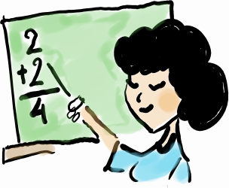



[NAME OF THE SCHOOL]
[ADDRESS]
[POSTCODE] Warsaw
[PHONE NUMBER]
[E-MAIL]
[SCHOOL WEBSITE]



This brochure uses materials from "Welcome pack for pupils and parents" prepared as part of the international project “Caerdydd-Warsaw Integration Project. Social integration among young people and their parents through education," managed by:
Warsaw
The Education Department of the City of Warsaw, “Arteria” Art Foundation, Janusza Korczak's Primary School No. 211 with Integration Classes, Leopold Staff's Gimnazjum No. 14 with Integration Classes
Cardiff
Cardiff County Council, Race Equality First, St. Mary’s Catholic Primary School, Michaelston Community College
In the years 2009-2011. This project is being aimed at actions to support children and young people from abroad. The brochure was prepared thanks to co-financing from the funds of the Lifelong Learning Programme, Comenius Regio component.

Authors: Anna Miastowska, Ewa Pawlic-Rafałowska, Katarzyna Rogalska, Monika Spurtacz, Małgorzata Zasuńska



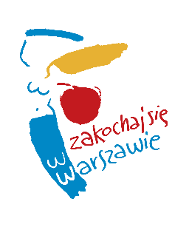

Good day! Hello! Hi!

Dear Pupil! Welcome to Warsaw and to your new school! We are very pleased that you have come to us, that you will be living here, that you will study and play in Warsaw. We hope that you will like Warsaw, as this is a city which has been created by newcomers from various countries for centuries. The multi-cultural Warsaw of today is proud that so many foreigners consider it their second home.
We would like to help you in your first days in the new school. There are teachers and schoolmates around you that you can turn to for support and explanation regarding new, as yet unknown things. Remember – we are here to answer your questions and doubts.
We would like to hear the stories of your family, friends, the place you came from, about your favourite dishes and music. This way we will get to know each other better.
We encourage everyone in our city to “Fall in love with Warsaw” – we hope that it will soon become very close to you.

Joanna Gospodarczyk
Director of the Education Department
of the City of Warsaw

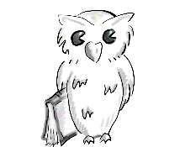

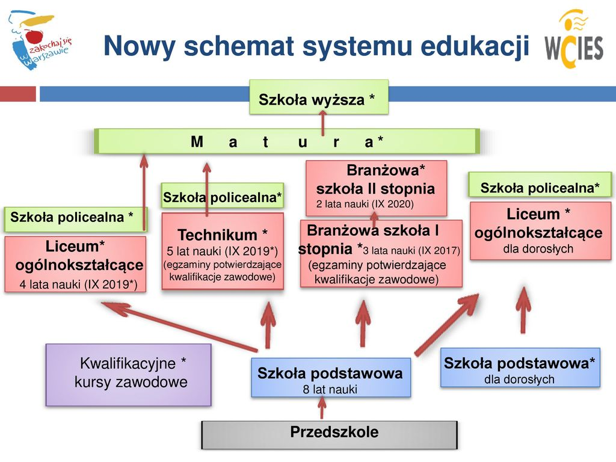
The New Education System in Poland

College of further education or university

The Matura exam

Supplementary general secondary school / Supplementary secondary vocational school / Supplementary secondary school

General Secondary School 4 years (from IX 2019)
Technical secondary school 5 years (from IX 2019) (exams confirming vocational qualifications)
Stage I sectoral vocational school 3 years (from IX 2017) (exams confirming vocational qualifications)
Stage II sectoral vocational school 2 years (from IX 2020)
General secondary school for adults

Qualification vocational courses
Primary school 8 years
Primary school for adults

Nursery school
First name:

Surname:

Class:

Form tutor:

Directions
[please, copy your map here]

[Name of the school]
[School's address]
[Postcode] Warsaw
[Phone number]
[Email address]
[School's website]

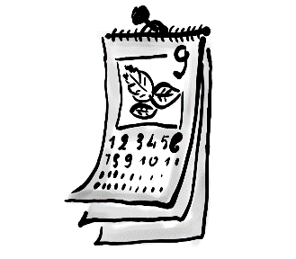
The school calendar

MONTH | HOLIDAYS/DAYS OFF
September (9) | 01.09. The beginning of the school year
October (10)
November (11) | 01.11. All Saints' Day (a day off)  11.11. Independence Day (a day off)
December (12) | 23.12-01.01. Christmas break  24.-26.12. Christmas
January (1) | - New Year's Day (a day off)  - Epiphany Holiday
January (1) or February (2) | Winter holidays – 2 weeks (as decided by the Ministry of National Education)
March (3) | Easter break – 6 days off (in March or April)
April (4)
May (5) | 01.05. Labour Day  03.05. May 3rd Constitution Day
June (6) | The end of the school year (last week in June)
July (7) | Summer holidays
August (8) | Summer holidays

*The school will inform you about any other days off.

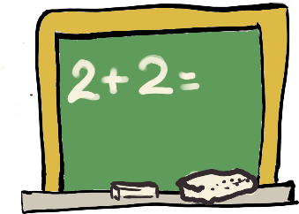
Daily timetable*
Lessons start at 8.00 every day.
Time | Lesson/ Break
8.00 – 8.45 | Lesson 1
8.45 – 8.55 | Break 1
8.55 – 9.40 | Lesson 2
9.40 – 9.55 | Breakfast break
9.55 – 10.40 | Lesson 3
10.40 – 10.50 | Break 3
10.50 – 11.35 | Lesson 4
11.35 – 11. 55 | Lunch break  grades I-III
11.55 – 12.40 | Lesson 5
12.40 – 13.00 | Lunch break  grades IV-VIII
13.00 – 13.45 | Lesson 6
13.45 – 13.50 | Break 6
13.50 – 14.35 | Lesson 7
14.35 – 14.40 | Break 7
14.40 – 15.25 | Lesson 8

Lessons end on Fridays. We go back to school on Mondays.
Note! In grades I-III you will get a detailed daily timetable from your form tutor.
* Please provide your current daily timetable


Things you need at school

- books

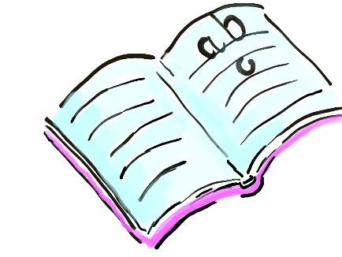
- workbooks


- a pencil

- scissors


- a ruler
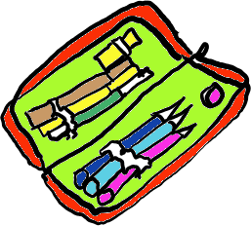
- a pencil case


- paint

- a sharpener

- a pen

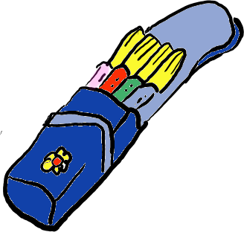
- crayons
- marker pens

Your pupil's diary*

- Your pupil's diary will remind you about important school matters. 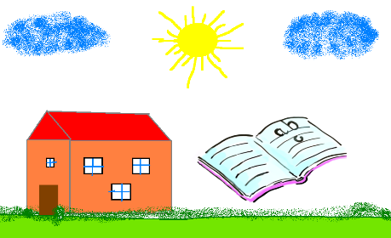

- In your pupil's diary you will find a timetable for every day.
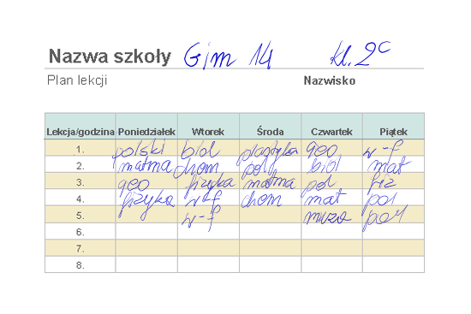

- Your parents will read about important events at school (meetings, parent-teacher meetings, school excursions) and about your conduct and learning process).
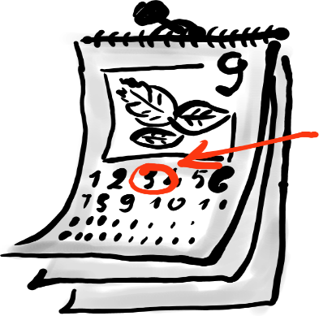

*If your school uses an electronic pupil's diary or any other tool for contacting parents, please describe it in this part of the Welcome pack.

Breaks

You must stay at school during breaks!

Places you can stay at during breaks:

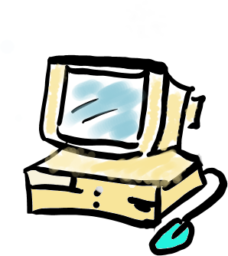
- library

- reading room

- school corridors (pupils in grades IV – VIII)

- gymnasium – check what hours are for your class to spend your breaks there.

- school sports field – only under your teacher's care: in spring, summer and autumn.
- playground – under your teacher's care (pupils in grades 0/I – III; children staying in the school common room)
- other (please specify other places where pupils are allowed to stay during breaks)
During breakfast breaks you can eat your breakfast in the classroom.
During lunch breaks you can eat your lunch in the school canteen.

You can have free lunch, if it is arranged with a school counsellor.



Extra-curricular activities*

Extra-curricular activities for pupils from abroad | - Extra Polish lessons (at least 2 hours a week)
Extra-curricular activities for pupils from abroad | - Catch-up classes (1 lesson a week in the subject the pupil has fallen behind in - for up to 12 months)
Extra-curricular activities for all pupils | - Interest clubs (you can choose from several subjects available)  - Clubs developing pupils' interests
Extra-curricular activities for all pupils | - Sports classes  - Library, computer labs
Extra-curricular activities for all pupils | - Activities in the common room
Extra-curricular activities for all pupils | - Catch-up classes
Extra-curricular activities for all pupils | - Swimming

* Specify what extra-curricular activities your school offers.

What to do if:
I WAS ABSENT FROM CLASS


I bring an excuse note from my parents or a doctor, and give it to my form tutor.

I'M LATE


I go to my classroom and say "I'm sorry for being late" ("Przepraszam za spóźnienie”)

I'M FEELING UNWELL
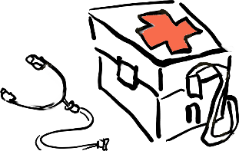

I talk to my form tutor or the school nurse. They will talk to my parents and arrange who will pick me up from school.

I HAVE A PROBLEM
I'VE HAD A QUARREL WITH A FRIEND FROM SCHOOL | I CAN'T DO MY HOMEWOK BY MYSELF
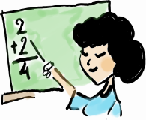
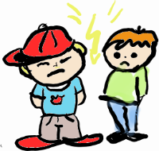

I talk to my school counsellor or psychologist. | I talk to my form tutor, other teachers or the school counsellor.

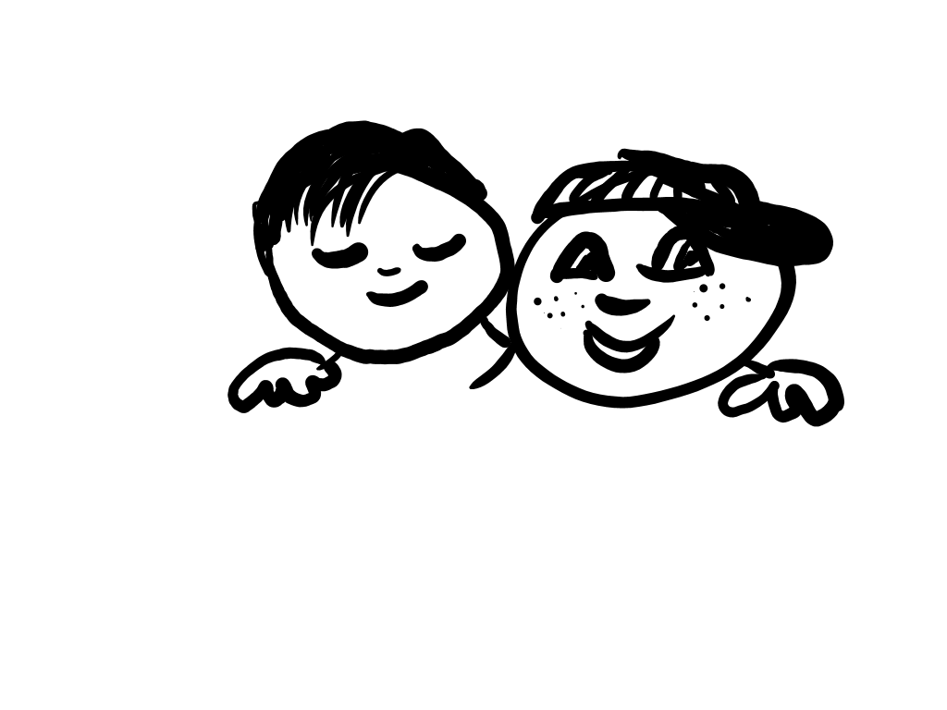
How to make friends with other pupils at school

- Your form tutor will introduce you to your new class.

- You will have plenty of time to find new friends.

- Some of your classmates are more sociable, while others might be shy. This doesn’t mean they don’t want to be friends with you.

- We often have new pupils at school. Some friends you meet may have been here only as long as you have.



System of grades at our school

If you are a pupil of:

- Grades 0/I-III

You and your parents get ongoing information about your current learning progress and conduct, and a summary at the end of each term.

- Grades IV-VIII

- You are graded from 1 to 6.
- Teachers grade your progress day to day.
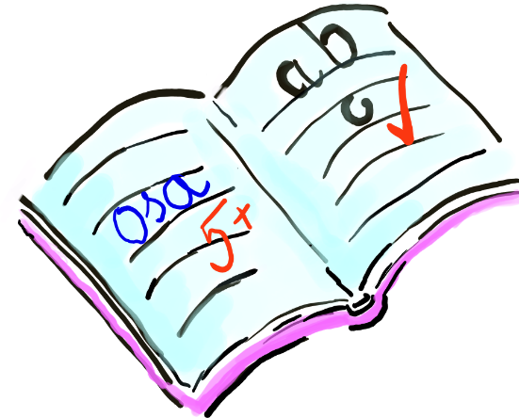
- At the end of each term and year teachers give you final grades for every subject and for your conduct.

Grades from 1 to 6
6 – excellent (++++++)
5 – very good (+++++)
4 – good (++++)
3 – satisfactory (+++)
2 – poor (++)
1 – unsatisfactory (fail) (-)

Your conduct will be graded in this way:
- exemplary
- very good
- good
- acceptable
- unacceptable
- reprehensible

School forms templates

NOTIFICATION
School management/form teacher informs that Class …………. parents-teacher meeting is going to take place on (date) ……………………. at (time) …………………… in classroom …….…
Your attendance is obligatory.

…………………………………..
school management/form tutor’s signature

PARENT'S NOTE

I would like to excuse my daughter's/son's ………………………….……………………………… ………………………. (her/his name and surname) absence from school on (date) ………………..
because of her / his illness / medical examinations / other important family reasons.

…………………………………………
Parent's signature

EXEMPTION FROM CLASSES
I would like to ask you to exempt my daughter / son (her / his name) …………………….. ………………………………………..… from classes on (date) …………………………….
at (time) …………………..

……………………………………….
Parent's signature

PARENT CONSENT
I give my consent to my daughter's / son's …………………………..……………… (her/his name and surname) participation in a school / integrating / green school trip to …………………………… (destination) on …………………………… (the date)

……………………………………….

Parent's signature

Minidictionary of basic school terms
PL | RUS. | UKR. | CHECH. | VIET. | ENG. | ARAB.
Rok szkolny  W Polsce nauka rozpoczyna się 1 września, a kończy w ostatnim tygodniu czerwca następnego roku. | . |  |  |  | School year  In Poland it starts on 1st September and ends last week of June the following year.
Semestr  To połowa roku nauki: semestr zimowy trwa zazwyczaj od września do końca stycznia, semestr letni – od lutego do czerwca. |  |  |  |  | Term  This means we are half way through the school year: the winter term is usually from September till the end of January, the summer one — from February till June.
Przerwa semestralna  Po pierwszym semestrze uczniowie w Polsce mają dwutygodniową przerwę w nauce – ferie zimowe. |  |  |  |  | Term break  After the first term students in Poland have two-week half-term winter break
Wakacje  To czas wolny od nauki w ciągu lata. Trwa od ostatniego tygodnia czerwca do końca sierpnia. |  |  |  |  | Holidays  It means time free from schoolwork in the summer. It lasts from the last week of June till the end of August.
Wywiadówka  To spotkanie rodziców z nauczycielem/nauczycielami ucznia. Jego celem jest omówienie postępów dzieci w nauce oraz innych ważnych spraw dotyczących życia szkoły. |  |  |  |  | Parents-teacher meeting  It is parents’ meeting with teachers. It enables parents and teachers to talk about pupil's progress at school and/or other important matters regarding school life.
Ocena  Począwszy od czwartej klasy szkoły podstawowej uczniowie są oceniani przy pomocy skali od 1 do 6. 6 to ocena najwyższa. 1 to ocena najniższa. Od ucznia oczekuje się opanowania materiału co najmniej na 2. |  |  |  |  | Grades  From the 4th class of primary school onwards pupils get grades ranging from 6 (the highest) to 1 (the lowest). A pupil is expected to become familiar with certain school material within at least grade 2.
Biblioteka  Miejsce, gdzie uczeń może na miejscu, bezpłatnie skorzystać ze szkolnych zbiorów książek. Może też wypożyczać książki do domu. |  |  |  |  | The library  It is a place where a pupil can make use of all the school books free of charge. The books can also be borrowed and taken home.
Dyrektor szkoły  Osoba, która kieruje szkołą. |  |  |  |  | Head teacher  It is the person who manages the whole school.
Pedagog szkolny  Specjalista pomagający dzieciom, które mają trudności szkolne. |  |  |  |  | School counsellor  It is a specialist who helps children with difficulties at school.
Psycholog szkolny  Specjalista, który pomaga uczniom radzić sobie z trudnymi emocjami i uczuciami. |  |  |  |  | School psychologist  A specialist who helps pupils cope with difficult emotions and feelings.
Poradnia psychologiczno-pedagogiczna  To miejsce, gdzie specjaliści badają dzieci pod kątem ich możliwości korzystania z edukacji. Pomagają dzieciom, które napotykają bariery w edukacji. |  |  |  |  | Psychological and educational center  It is a place where specialists examine children’s educational capabilities and help those who face any educational difficulties.
Nieobecność  W Polsce dzieci mają obowiązek chodzić do szkoły, dopóki nie skończą szkoły podstawowej. Jeśli dziecko nie przyjdzie jakiegoś dnia do szkoły, rodzice są zobowiązani napisać ‘usprawiedliwienie’, czyli wyjaśnić, dlaczego dziecko nie przyszło do szkoły. W przypadku dłuższych nieobecności wywołanych kłopotami ze zdrowiem szkoła oczekuje zwolnienia lekarskiego, czyli dokumentu od lekarza, który potwierdza, że dziecko było chore, co uniemożliwiło mu przybycie do szkoły. |  |  |  |  | Absence  In Poland children are obliged to attend school until they finish primary school. If a student is absent from school, his/her parents should write a parents' note, that is an explanation of the reason of the absence. In the event of longer absence due to health problems, the school requires a doctor’s note which is a doctor's certificate which confirms the child's illness, which prevented the pupil from attending classes..
Egzamin  Już na koniec szkoły podstawowej uczniowie zdają egzamin – czyli sprawdzian zewnętrzny, badający poziom wiedzy i umiejętności zdobytych w szkole. |  |  |  |  | The exam  Pupils in Poland take an exam at the end of primary school — it’s an external exam testing their knowledge and skills acquired at primary school.
Długa przerwa/przerwa obiadowa  To dłuższa przerwa w godzinach południowych (około 20 minut), w czasie której dzieci mają czas zjeść posiłek. W niektórych szkołach w Polsce są stołówki, gdzie dzieci mogą zjeść obiad. Gdy nie ma stołówki – jedzą przyniesione z domu kanapki. |  |  |  |  | Long break/lunch break  It is a long break around noon (lasting about 20 minutes). Children can eat lunch then. In some schools in Poland there are school canteens where children can have lunch. If there is no school canteen, they eat sandwiches prepared at home.
Przerwa  To czas krótkiego odpoczynku dla uczniów między lekcjami, zwykle trwa 10 minut. Lekcje trwają 45 minut. | . |  |  |  | Break  It is a short period of time, between the lessons — it is usually about 10 minutes long. A lesson lasts 45 min
Grono pedagogiczne  To zespół nauczycieli uczących w danej szkole. |  |  |  |  | Teaching Staff  All the teachers working at the school.
Pokój nauczycielski To specjalna sala w szkole przeznaczona dla nauczycieli. Tam można znaleźć nauczycieli w czasie przerw. |  |  |  |  | Staff room  It is a special room for teachers. You can find teachers there during breaks.

